Smart Fire Fighting

**Sparsh Gupta, Vikas Kumar, Tushar, Sandeep Kumar**

Computer Science and Engineering Department

M S Ramaiah Institute of Technology

Bangalore, India

**Abstract**: Fire losses throughout the world remain too high and fire fighting too hazardous. The fire service and other emergency first responders are currently benefiting from enhanced-existing and newly-developed electronic technologies. Fire fighters are now operating in an ever increasing sensor rich environment that is creating vast amounts of potentially useful data. The "smart" fire fighter of tomorrow is envisioned as being able to fully exploit select data to perform work tasks in a highly effective and efficient manner.

Available data, the comprehensive ability to analyse and process this data, and an increasingly sensor rich environment are all opening new possibilities for the fire service to address unwanted fires. This involves all manner of their job performance duties, and includes during pre-fire, trans-fire (i.e. during the event) and post-fire stages. This project is focused on developing the research roadmap to clarify the research needed to most effectively use the immense quantity of available data, the computational power to compute and communicate that data, the knowledge base and algorithms to most effectively process the data, convert it into significant knowledge/beneficial decision tools, and effectively communicate the information to those who need it --- on the fire ground and elsewhere.

This project senses the temperature and smoke in a room and sends the data to the cloud. In case of fire an emergency message is sent to the cloud server which can be analyzed by the nearest fire rescue team and the proper action will be taken.

The use of technology, referred here as Smart Fire Fighting, includes all areas of fire protection engineering and phases of fire service emergency response: pre-incident, during-incident, and post-incident. Smart Fire Fighting will transform traditional fire prevention and protection strategies and fire-fighting practices by ensuring the flow of critical information where and when it is needed. This flow will be achieved by increasing the power of information through enhanced data gathering, processing, and targeted communications.

Keywords: Smart Fire Fighting, Internet of Things, sensors, cloud computing

1. **Introduction**

The Internet of Things (IoT) is the network of physical objects or "things" embedded with electronics, software's, sensors, and network connectivity, which enables these objects to collect and exchange data. The Internet of Things allows objects to be sensed and controlled remotely across existing network infrastructure, creating opportunities for more direct integration between the physical world and computer-based systems, and resulting in improved efficiency, accuracy and economic benefit.

"Things," in the IoT sense, can refer to a wide variety of devices such as heart monitoring implants, electric clams in coastal waters, automobiles with built-in sensors, or field operation devices that assist firefighters in search and rescue operations. These devices collect useful data with the help of various existing technologies and then autonomously flow the data between other devices.

Today, data from a variety of sources are collected independently and processed separately, but evolving new technologies are enabling the use of vast amounts of information. The use of this information continues to demonstrate great promise at enhancing the effectiveness

and efficiency with the duties handled by fire fighters. Importantly this equates to improved safety and health for this high risk profession, via situational and incident awareness and other factors. Knowledge is power, and harvesting the data important to fire fighters is empowering the smart fire fighter of the future.

When it comes to putting out fire, time is often the most important factor to consider. Time, and information. The more data about the burning structure – and the people trapped in it – is available to firefighters, the more they can operate effectively, saving lives and limiting the damages to the building.

There are four things that are most important to the development of smart fire fighting technologies:

* use of sensors on the fire ground to assist in situational awareness and personnel location;
* increased collection and utilization of data before the incident to aid in effective use of personnel and equipment;
* enhance interoperability between data systems; and
* develop intelligent systems to assist with decision-making.

Smart Fire Fighting demonstrates how enhanced data gathering, processing and delivery could transform traditional fire protection and fire fighting practices, combining the points of strengths of "Internet of Things" with the big data analytics.

The vision to improve fire protection and fire fighting is undertaken with the following motivations:

* To save lives and minimize injuries to building occupants and community members due to fire.
* To improve fire fighter occupational health and safety.
* To enhance the operational efficiency of the fire service and the effectiveness of fire protection.
* To minimize property loss from fire.
* To minimize business interruption and loss of mission continuity due to fire.

This paper is organized as follows: Section 2 gives a description of design of project including the architecture. Section 3 gives a description of implementation. Section 4 includes testing. Section 5 provides experimental results. Section 6 describes the security protocols in IoT. Section 7 includes technical challenges. Section 8 describes the current scope and future work. Section 9 provides conclusion of the paper. Section 10 gives references.

1. **DESIGN**

The goal for Smart Fire Fighting is to remove unwanted fire and other harmful events as a limitation to life safety, technical innovation, and economic prosperity. It remotely measures the room temperature and smoke variations using **Raspberry Pi 2**.

**Architecture Design -**

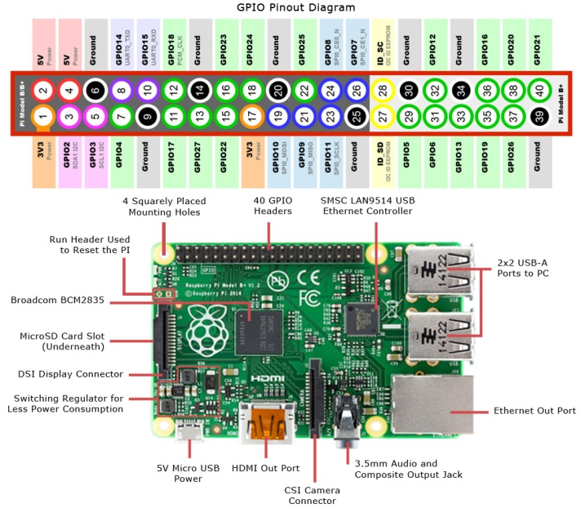

*Fig. Architecture of Raspberry Pi 2*

The project is a new, self-contained product intended for use on the Raspberry pi platform. There is a server-side component which will be responsible for database and synchronization services using open source Cloud services such as Ubidots.

The scope of the project encompasses both server- and client-side functionalities

A **DS18B20** sensor is used to measure real time temperature and **MQ2** sensor is used to measure smoke levels. Both the sensors update the readings in **Open Source Cloud** and in the **database**. The temperatures are constantly monitored and printed on the console. Also an **email** **alert** is sent to the intended recipient if the inside room temperature or smoke levels exceeds a certain predefined limit.

**Product Features**

The following list offers a brief outline and description of the main features and functionalities of the Smart Fire Fighting system.

***Core features -***

* The sensors senses the environment around it and continuously sends data to the cloud server.
* The cloud server is integrated with the fire fighting departments so that the data can be read by authorized persons and detect whether a fire hazard is going to occur or has occurred or not.
* Synchronizes to a computer to obtain databases previously downloaded from a web application, using a password-protected secure login.
* Push Notifications appears if any significant event occurs. It alerts the members.

***Additional Features -***

* GPS Tracking : Stores data and utilizes Google maps to display the location from which the data is sent using the location of the IP address of raspberry pi.

**Design Constraints**

1. Synchronization:

* Uses USB 3.0.
* Connects only to Windows 7 and above.

2. Memory:

* Device will have 16GB class 10 SD card. Software and database cannot exceed this amount.
* Device will have a SD card slot, and the software must be able to read and write to that slot.

3. Language requirements:

* GUI is available only in English.

4. Login and password is used for the identification of users. Only authorized users will receive notification alerts.

1. **IMPLEMENTATION**

**ALGORITHM -**

The following algorithm is implemented for Smart Fire Fighting System

readSensorData(); // reads the data from smoke and temperature sensor

 if somkeFound() or temperature > someFixedValue onBuzzer();

triggerEvent(); // send the mail to the respective user

uploadDataOnCloud();

displaySensorData();

readSensorData():-

This function reads the raw data from the two sensors which we have used i.e smoke sensor(MQ2) and temperature Sensor(DS18B20). The smoke value is read as digital value which if is high then smoke is detected. The temperature sensor is a one wired digital temperature sensor which senses the room temperature in the range of -55C to +125C with an error of +-0.5C.

onBuzzer():-

Here if the value returned from the readSensorData() function if returned as true then the high value is passed to the vcc and the buzzer is switched on.We also have a code snippet here which tracks when the value becomes low and then it turns the buzzr Off.

triggerEvent():-

The values of the readSensorData() is used to trigger events such as sending an message, sending an email or setting the value of any variable.

updateDataOnCloud():-

The data which is being read from the sensors is uploaded to the cloud using this function for further analysis and event triggering process.

displaySensorData():-

The data which is uploaded on the cloud can be viewed using this function.

1. **TESTING**

**Finding Your Raspberry Pi’s System Information**

The Raspberry Pi has a lot of system information available like details about the CPU, the current temperature of the processor, the amount of memory and so on.

Besides the “standard” system resource tools like “ps“, “df“, “top” and other useful commands like “htop”, “iotop” and “glances”, system information can be found under the “/proc” filesystem. One of the most useful is the “cpuinfo” file, which contains data on a system’s CPU. To see it type :

**cat /proc/cpuinfo**

**Connecting Raspberry Pi to Laptop**

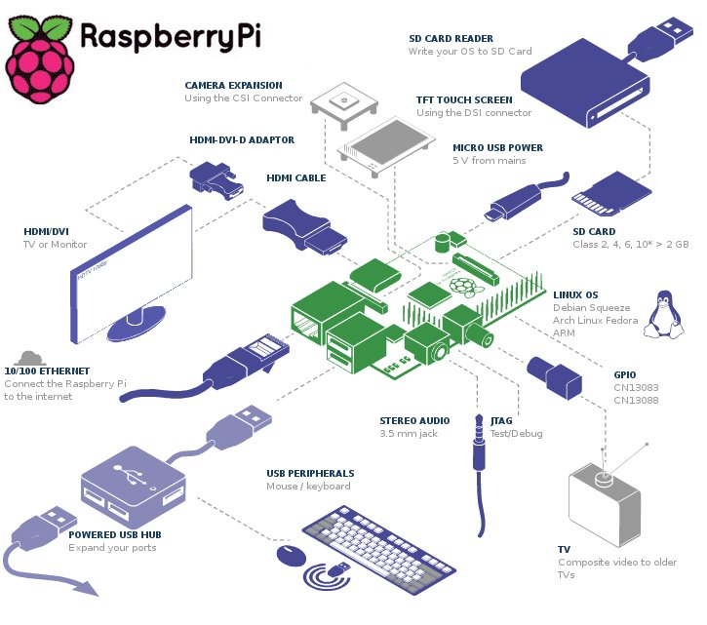

*Fig. 4 Testing Raspberry Pi 2*

1. **RESULTS**

The results are generated after executing the code by reading values from the sensors. The sensor readings are also uploaded to cloud and notifications are sent to authorized users if an unwanted result occurs i.e. when temperature is greater than 70 degrees centigrade or smoke levels exceeds a certain value.

**Sensor Output**

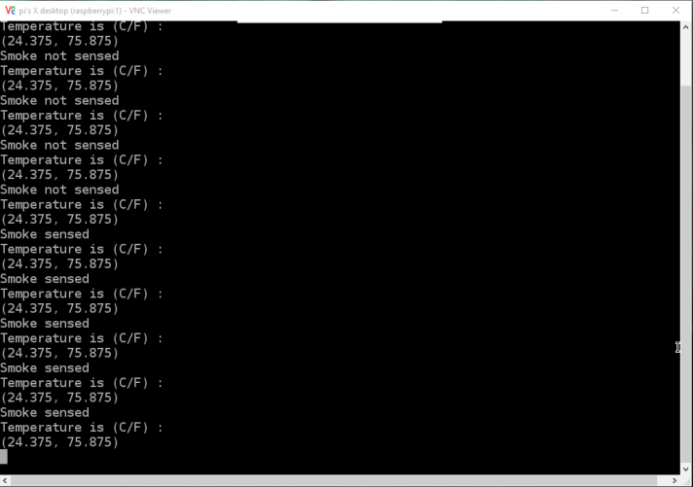

*Fig.5 Sensor Readings*

**Ubidots Smoke Source**

This source contains the value of smoke. If the smoke value, which is a digital value, is 1 means smoke is detected else smoke is not detected.

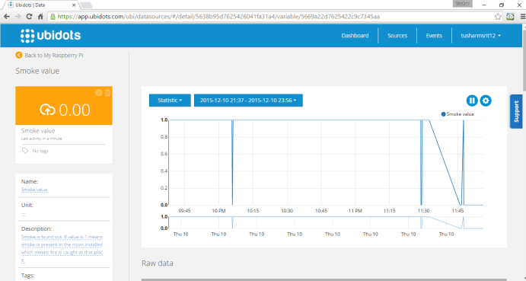

*Fig. 6 Smoke Reading on Ubidots*

**Ubidots Temperature Source**

This shows the temperature source. It shows the different temperature sensed by the sensor per second. A graph is also present which shows the previous data of the temperature.

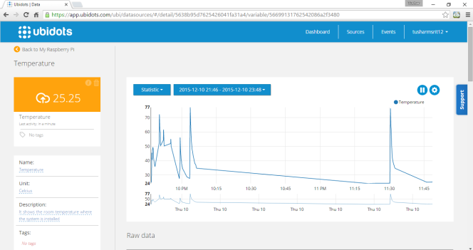

*Fig. 7 Temperature Reading on Ubidots*

**Email Notifications**

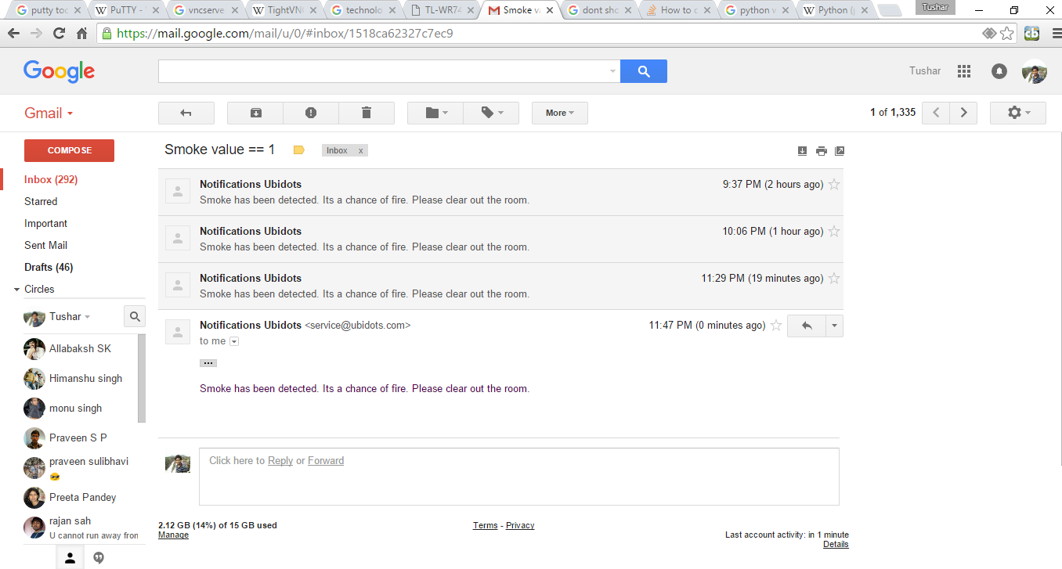

*Fig.8 Notifications*

1. **SECURITY PROTOCOL FOR SMART FIRE FIGHTING**

The Internet of Things (IoT) is growing by leaps and bounds every day. But as the IoT grows, so do the security vulnerabilities of the linked objects. A security protocol to protect IoT devices will always be needed.

**Building In Security Measures for the Smart Fire Fighting System-**

There are some obvious things that can be done to embed security in the IoT.

* The most obvious one is securing the Web interface of the device. Simple things like making sure that default usernames and passwords are changed during initial setup helps greatly. And the changes shouldn’t allow the use of weak passwords. Perhaps measures such as an account lockout after three to five failed login attempts should be considered.
* Attention should be paid to passwords beyond just initial setup changes. Checking network traffic to ensure login codes are not being sent in cleartext is a wise move, and that goes for any password recovery schemes, as well. Additionally, two-factor authentication may be needed for sensitive areas like administrator accounts.
* Examining the Web interface for resistance to common attacks like cross-site scripting, cross-site request forgery and SQL injection should be done, too. These attacks are harmful if successful, but they’re also relatively simple in nature, which makes them preventable with the right proactive safeguards.
* One trick attackers use involves scanning for open ports with a special program and then exploiting those ports. Universal Plug and Play (UPnP) has only exacerbated this problem by standardizing network access points. Open ports can now be used to launch denial-of-service (DoS) attacks as well as buffer overflow attacks across networks and devices.

1. **TECHNICAL CHALLENGES**

A large number of standards associated with Smart Fire Fighting remain to be resolved, including the following issues :

* Secure standard methods of transmitting a standard set of data in a standardized format.
* Standardized information for first responders and standard building data models.
* Choice of standard communication protocols and user interfaces.
* Establishment of criteria to automatically route 1-0-1 calls based on message content.
* Implementation of appropriate authorization, authentication, and security protocols.
* Standards for accessing and using cloud-based services.
* Plug-and-play architectures that facilitate integration of components.

1. **SCOPE AND FUTURE WORK**

The scope of the project is to prepare a SMART system that will enhance the fire rescue team efficiency in controlling and rescuing people in fire. The system should be -

* ***S****calable* and robust and provide custom information at appropriate periods and in suitable data forms, as required by different applications and services.
* ***M****onitored and managed*easily. If software on remote sensors must be updated, the sensors need to be discoverable no matter where they are. That requires an efficient management approach.
* ***A****daptable* to the sensors changing conditions or context while being able to communicate automatically to other sensors.
* ***R****eliable.* Data uploaded wirelessly to a cloud must be dependably transmitted and reported.
* ***T****rustworthy.* A mechanism is needed to ensure data are not being manipulated while in transit and that only trusted parties can access sensitive data.

The purpose of this project is to provide an overview of the current state and future trends of Smart Fire Fighting. Today’s fire fighting and fire protection environment is data poor and without integrated analysis and decision making. Changing this situation will require new types of technologies.

With the advancements in technologies, IoT will lead to the following in future in respect to Smart Fire Fighting

a) Almost all things will work on your voice in future

b) "Almost Everything is in Control with IoT"

c) You will control the inside environment of your home from outside.

1. **CONCLUSION**

The word Smart is appearing everywhere these days. Instances include Smart Machines, Smart Grid, Smart Manufacturing, Smart Cities, and Smart America, just to name a few. This trend is expected to increase. Although some smart systems are already implemented, huge challenges remain in terms of engineering these products and systems to attain their full potential. A key area, ripe for development, is Smart Fire Fighting.

This project identifies and prioritizes the research and development needs for implementation of the next generation of smart systems to benefit fire protection and fire fighting. The idea of Smart Fire Fighting is based on creating, storing, exchanging, analyzing, and integrating information from a wide range of databases and sensor networks. There are many challenges that must be overcome to exploit the promise of smart technologies.

The vision of Smart Fire Fighting can be realized by harnessing the power of emerging information, communication, sensor, and simulation technologies to enable markedly better situational awareness, predictive models, and decision making.

The paper concludes in outlining four central areas where the best efforts must be put into in order to reach a reality of “smart fire-fighting”:

* Increased use of sensors during a fire event to increase awareness to the happenings in the field and the firemen’s location.
* Gathering more data and analyzing it in advance to manage more efficiently at the time of the event.
* Sharing mutual knowledge between different information systems.
* Developing smart systems that help the decision making process.

1. **REFERENCES**

[1]https://www.nedcc.org/free-resources/preservation-leaflets/3.-emergency- management/3.2-an-introduction-to-fire-detection,-alarm,-and-automatic-fire-sprinklers

[2]http://ubidots.com/

[3]http://www.govtech.com/fs/New-Era-in-Firefighting-Leverages-the-Internet-of-Things.html

[4]http://www.forbes.com/sites/federicoguerrini/2015/06/29/firefighters-and-the-internet-of-things/

[5]http://www.jbrehm.com/blog/2015/6/11/smart-fire-fighting-merging-iot-and-big-data-for-fire-safety

[6]http://www.criticallink.com/2015/07/firefighting-and-the-iot/

[7]http://www.nist.gov/el/fire_research/201506_smart_fire_roadmap.cfm

[8] IEEE Journals and papers - http://ieeexplore.ieee.org/

[9] http://blog.ubidots.com/topic/raspberry-pi